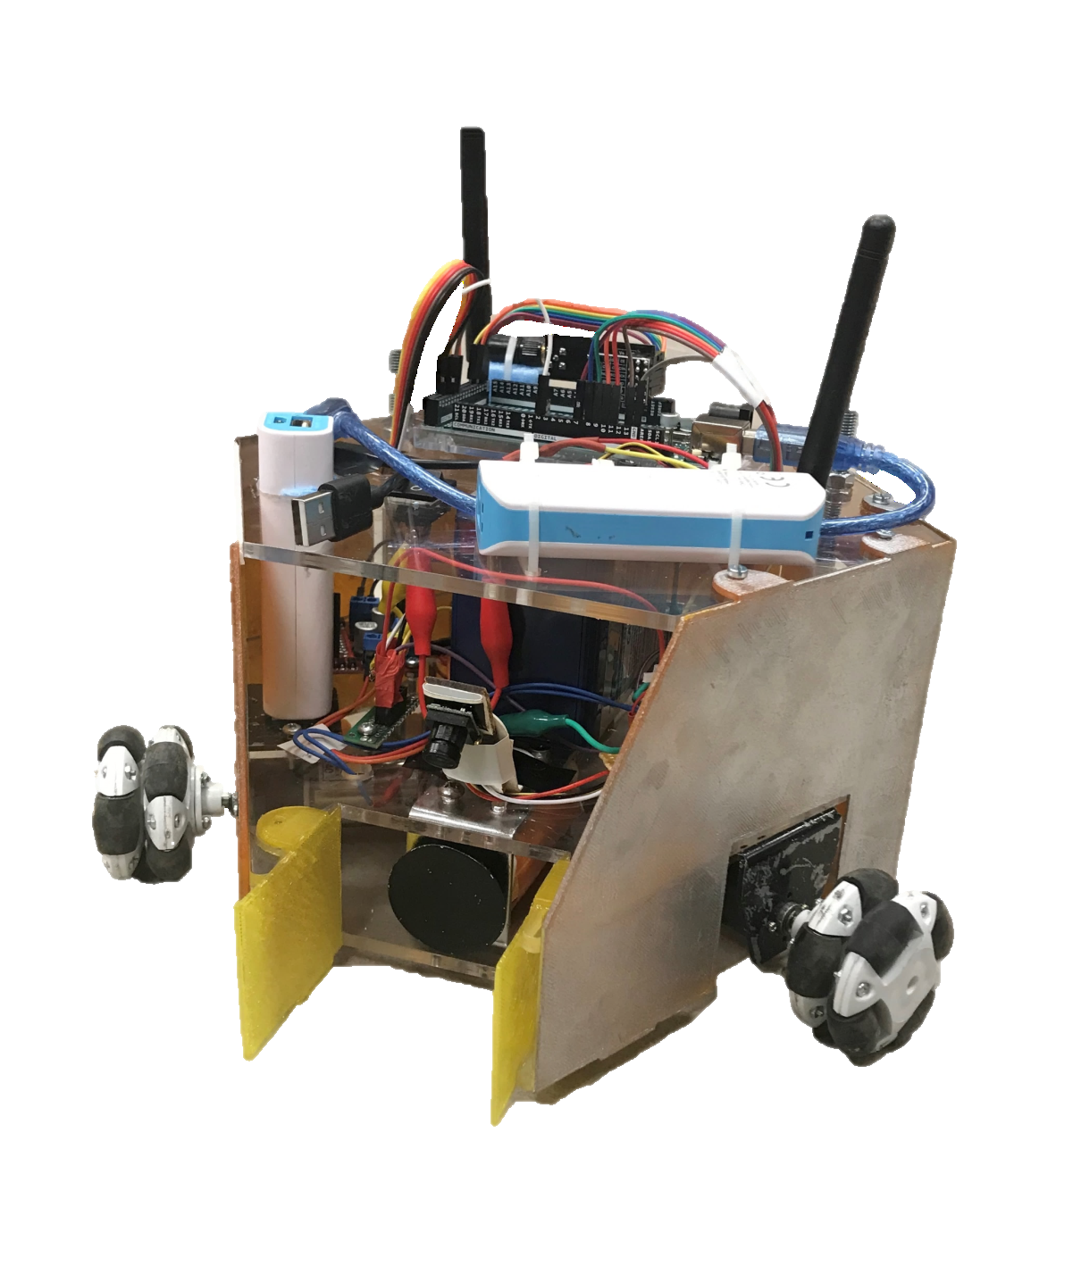

USER MANUAL

HELEN-V

*May 10, 2019*

Table of Contents

1. What’s inside the box 1

2. Quick Start Guide 2

3. Controls 3

4. Charging 4

5. Care and Maintenance 5

1. **What’s inside the box**

Your shipping box contains Helen-V (Fig. 1), Eachine ROTG02 FPV Receiver (Fig. 2), a command transmitter module with PS1 joystick (Fig. 3), Artengo beach volley ball (Fig. 4), playfield walls and charging cables. Remove all items carefully and do not discard your shipping box.

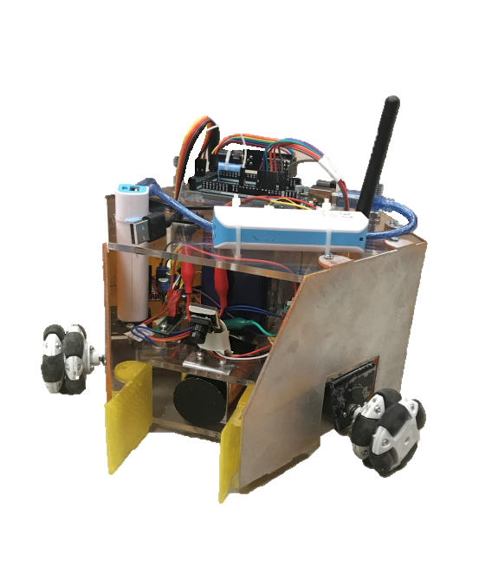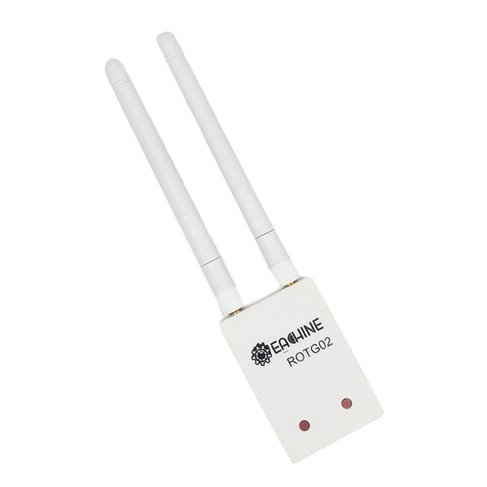

Figure 1. HELEN-V

Figure 2. Eachine ROTG02 FPV Receiver

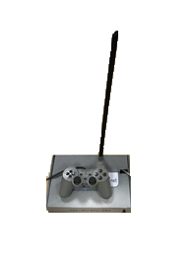



*Figure 4 .Artengo beach volley ball*

*Figure 3. Command Transmitter Module*

1. **Quick Start Guide**

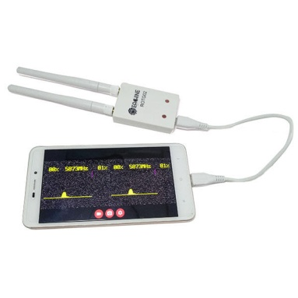

**1**



**2**





**5**

**3**

**4**

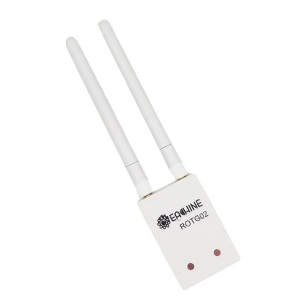



**5.8 GHz**

1. Install any FPV receiver app to your smartphone /tablet/PC (“GoFPV” is recommended.).
2. Connect “ROTG02 FPV Receiver” to your smartphone /tablet/PC..
3. Turn on HELEN-V and command transmission unit
4. Adjust the channel of “ROTG02 FPV Receiver” by pressing the adjust buttons. If you press any of these buttons 2 seconds, it will automatically set the channel.
5. You can start playing the game!
6. 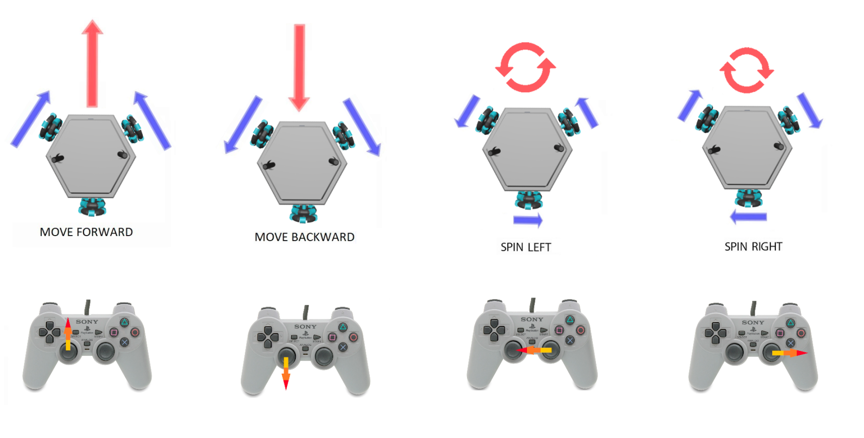**Controls**

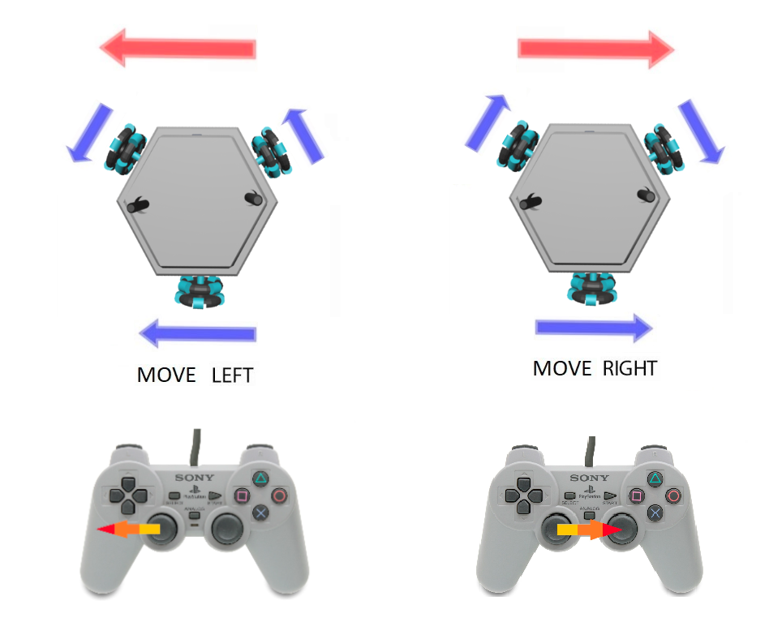

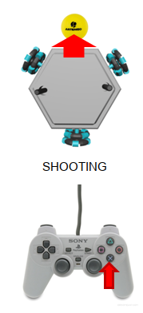

1. 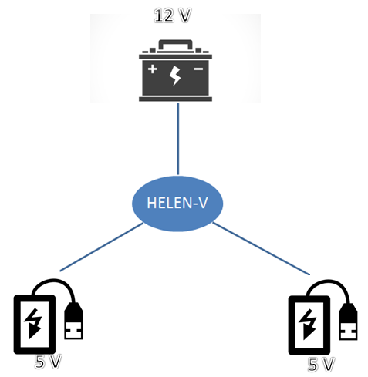**Charging**

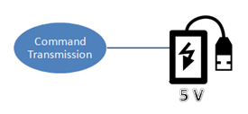

Helen-V includes 2 power-banks and a 12V (2.8Ah) accumulator battery. Moreover, command transmission system has a power bank. You can charge the power-banks with a simple micro-usb cable. You can charge 12V battery using DC supply or a 12 V battery charging adaptor.

**WARNING:**

- While charging the 12 V accumulator battery, make sure that other power-banks are switched off.

- Reverse charging is prohibited! Do not reverse the positive (+) and negative (-) terminals when charging the 12V accumulator battery.



1. **Care and Maintenance**

🡪Recharge the batteries after each use. Only an adult can handle the battery. Recharge the battery at least once a month when the robot is not being used.

🡪Store the robot where the temperature is between -20º and 45º C (-4º to 113º F). Don’t leave it in your car, because temperatures in parked cars can exceed this range.

🡪It does not have a waterproof function, so keep the robot out of water.

🡪Do not use the robot in loose dirt, sand or fine gravel which could damage moving parts, motors or the electric system.

🡪 When not using, all the electrical source should be turn off.

🡪In case of a technical problem, please contact Troy Tech, please do not try to fix the problem by yourself